DOMAIN:APPLIED DATA SCIENCE
PROJECT TITLE:CREDIT CARD FRAUD DETECTION
TEAM MEMBERS:
D.HARISH
M.MADHUSRI
J.KEERTHIKA
E.REVATHI
R.SWATHI
PROBLEM DEFINITION:
The problem is to develop a machine learning-based system for real-time credit card fraud detection. The goal is to create a solution that can accurately identify fraudulent transactions while minimizing false positives. This project involves data preprocessing, feature engineering, model selection, training, and evaluation to create a robust fraud detection system.Data preprocessing is an important step in the data mining process. It refers to the cleaning, transforming, and integrating of data in order to make it ready for analysis. The goal of data preprocessing is to improve the quality of the data and to make it more suitable for the specific data mining task.Feature engineering involves a set of techniques that enable us to create new features by combining or transforming the existing ones. These techniques help to highlight the most important patterns and relationships in the data, which in turn helps the machine learning model to learn from the data more effectively.In its most basic forms, model selection is one of the fundamental tasks of scientific inquiry. Determining the principle that explains a series of observations is often linked directly to a mathematical model predicting those observations. For example, when Galileo performed his inclined plane experiments, he demonstrated that the motion of the balls fitted the parabola predicted by his model.
DESIGN THINKING:
DATA SOURCE:

A data source is simply the source of the data. It can be a file, a particular database on a DBMS, or even a live data feed. The data might be located on the same computer as the program, or on another computer somewhere on a network.
TRANSACTION DATASET:
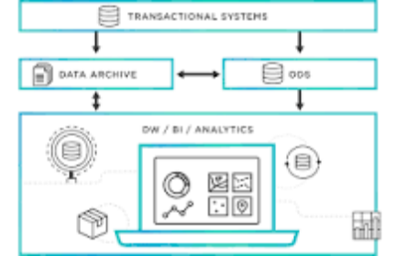
Transactional data is information that is captured from transactions. It records the time of the transaction, the place where it occurred, the price points of the items bought, the payment method employed, discounts if any, and other quantities and qualities associated with the transaction.
TRANSACTION AMOUNT:


A data source is the location where data that is being used originates from. A data source may be the initial location where data is born or where physical information is first digitized, however even the most refined data may serve as a source, as long as another process accesses and utilizes it.
TIMESTAM:
SQL Server timestamps are a data type used to store a date and time value. The timestamp data type stores a date and time value in the format YYYY-MM-DD HH:MM:SS. The timestamp data type is an 8-byte value representing a date and time value in the YYYY-MM-DD HH:MM:SS format.
MERCHANT INFORMATION:
The details about your products that you submit to the Google Merchant Centre. Your product data is used to show dynamic ads, free product listings and Shopping ads when you run a Google Ads campaign.
CARD DETAILS:
Ultimately, data sources are intended to help users and applications connect to and move data to where it needs to be. They gather relevant technical information in one place and hide it so data consumers can focus on processing and identify how to best utilize their data.
DATA PREPROCESSING:
Data preprocessing is an important step in the data mining process. It refers to the cleaning, transforming, and integrating of data in order to make it ready for analysis. The goal of data preprocessing is to improve the quality of the data and to make it more suitable for the specific data mining task.
PREPROCESS THE DATA:
Ultimately, data sources are intended to help users and applications connect to and move data to where it needs to be. They gather relevant technical information in one place and hide it so data consumers can focus on processing and identify how to best utilize their data. information in one place.
HANDEL MISSING VALUES:rs can focus on p
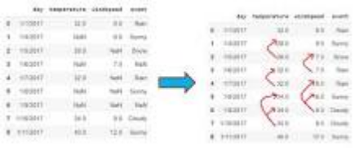
the deletion of the rows or columns having null values. If any columns have more than half of the values as null then you can drop the entire column. In the same way, rows can also be dropped if having one or more columns values as null.utilize their data.
NORMAIZE FEATURES:
Normalization is a data preprocessing technique used to transform features in a dataset to a common scale, improving the performance and accuracy of machine learning algorithms. The main goal of normalization is to eliminate the potential biases and distortions caused by the different scales of features.
FEATURE ENGINEERING :
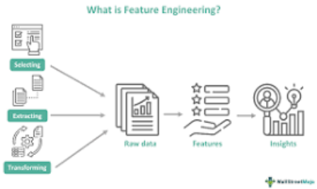
Feature engineering involves a set of techniques that enable us to create new features by combining or transforming the existing ones. These techniques help to highlight the most important patterns and relationships in the data, which in turn helps the machine learning model to learn from the data more effectively.
ENHANCE FRAUDE DETECTION :

Feature engineering is the key to success in modeling. Good feature engineering can capture the nature of the problem, thus rendering a better outcome. What is a feature? A feature is a variable that describes the latent patterns. In this article, I will survey feature engineering in the literature on credit card fraud. Readers will learn how other data scientists create features to attach fraud in different industries. In Feature Engineering for Healthcare Fraud Detection, I show you how to create features for the healthcare industry.
TRANSACTION FREQUENCY:
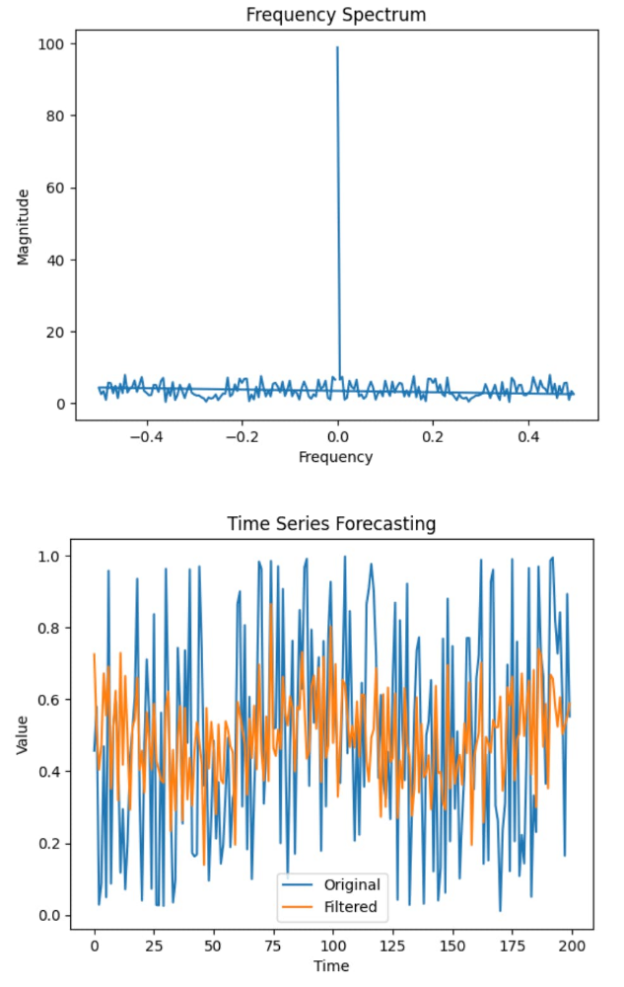
In this blog post, I would like to focus on feature engineering to predict customer transactions for the next month. As a data scientist working in marketing, I find it quite important to understand why I am doing some work and how it can solve a business problem. I think feature engineering is a part of an analysis where the domain knowledge and hard skills are equally important and blended to find a better solution to a problem.
AMOUNT DEVIATIONS:
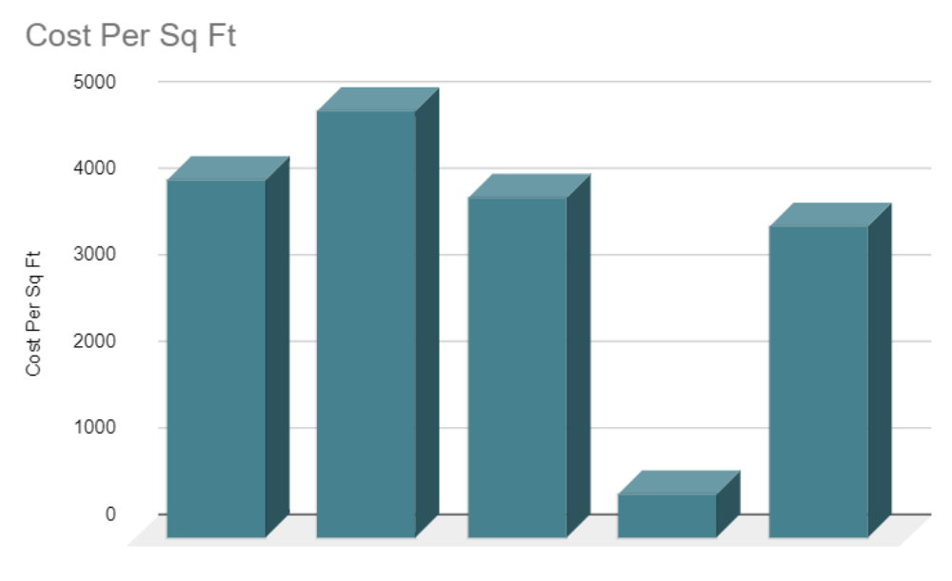
When you plot the data, youll notice that one price is significantly different from the rest. In the visualisation method, you can readily notice the problem. The third way is to use Statistics to analyze your data and find any problem. Feature engineering consists of various process.
MODEL SELECTION:
In its most basic forms, model selection is one of the fundamental tasks of scientific inquiry. Determining the principle that explains a series of observations is often linked directly to a mathematical model predicting those observations. For example, when Galileo performed his inclined plane experiments, he demonstrated that the motion of the balls fitted the parabola predicted by his model.
MACHINE LEARNING ALGORITHMS FOR FRAUD DETECTION:
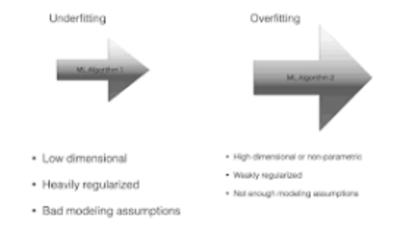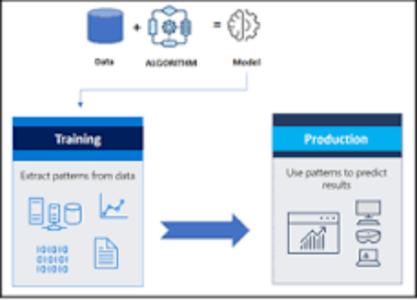
Model selection is the process of deciding which algorithm and model architecture is best suited for a particular task or dataset. It entails contrasting various models, assessing their efficacy, and choosing the one that most effectively addresses the issue at hand.
e.g.
Logistic Regression:
select all the variables whose p-value < 0.25 along with the variables of known clinical importance. Step 2: Fit a multiple logistic regression model using the variables selected in step 1. Verify the importance of each variable in this multiple model using Wald statistic.
MODEL TRAINING:
Model training is the phase in the data science development lifecycle where practitioners try to fit the best combination of weights and bias to a machine learning algorithm to minimize a loss function over the prediction range.
TRAIN THE SELECTED MODEL USING THE PREPROCESSED DATA:
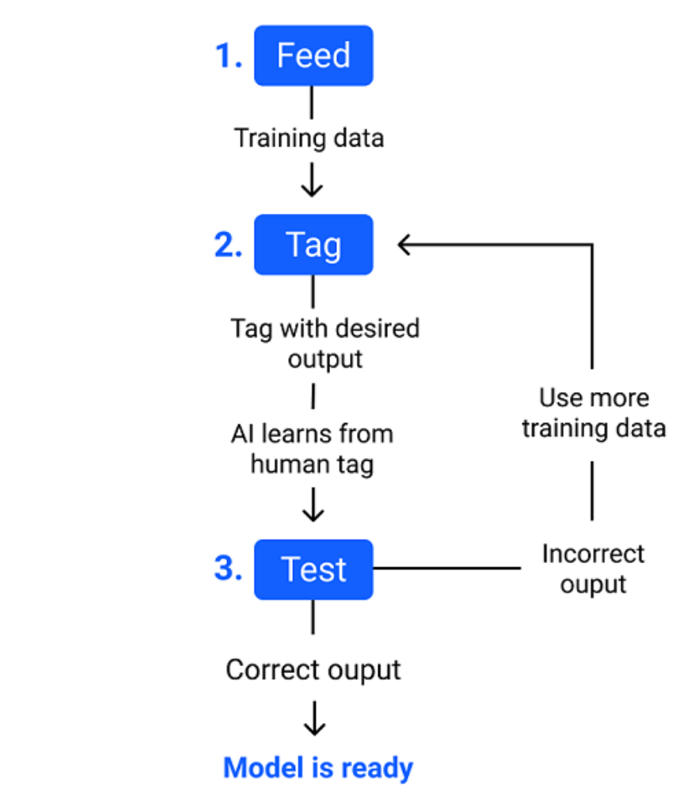

The main difference between training data and testing data is that training data is the subset of original data that is used to train the machine learning model, whereas testing data is used to check the accuracy of the model. The training dataset is generally larger in size compared to the testing dataset.
EVALUATION:
Evaluation is the structured interpretation and giving of meaning to predicted or actual impacts of proposals or results. It looks at original objectives, and at what is either predicted or what was accomplished and how it was accomplished. So evaluation can be formative, that is taking place during the development of a concept or proposal, project or organization, with the intention of improving the value or effectiveness of the proposal, project, or organisation.
EVALUATE THE MODEL'S PERFORMANCE USING MATRICS LIKE ACCURANCY:
Therefore evaluating a model plays a vital role so that we can judge the performance of our model. The evaluation also helps to analyze a model's key weaknesses. There are many metrics like Accuracy, Precision, Recall, F1 score, Area under Curve, Confusion Matrix, and Mean Square Error.What is the evaluation metrics for accuracy?
Accuracy means that how many data points are predicted correctly. It is one of the simplest form of evaluation metrics. The accuracy score is # of correct points / # total = (30 + 35 + 50) / 200 = 0.575.
PRECISION:
Precision evaluates how precise a model is in predicting positive labels. Precision answers the question, out of the number of times a model predicted positive, how often was it correct? Precision is the percentage of your results which are relevant.
RECALL:
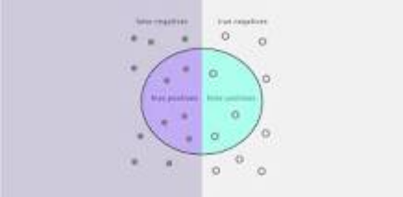

Recall in this context is defined as the number of true positives divided by the total number of elements that actually belong to the positive class (i.e. the sum of true positives and false negatives, which are items which were not labelled as belonging to the positive class but should have been).
F1-score :
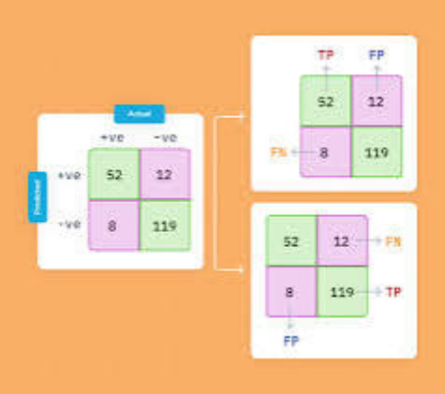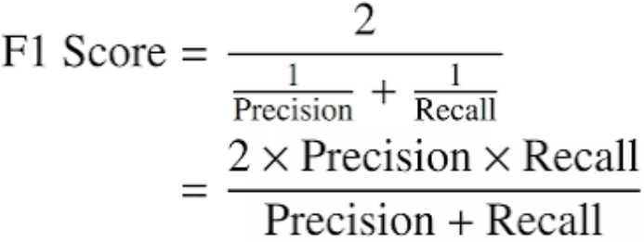
F1-score is the evaluation matrix that combines two matrices: Precision and Recall, into a single metric by taking their harmonic mean. In simple terms, the f1 score is the weighted average mean of Precision and Recall. It is also used in Natural Language Processing.
ROC-AUC:
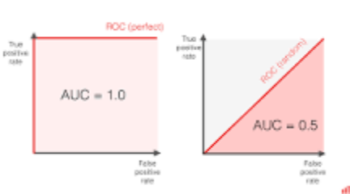

To get the score, you must measure the area under the ROC curve. ROC AUC score shows how well the classifier distinguishes positive and negative classes. It can take values from 0 to 1. A higher ROC AUC indicates better performance.
Innovation:

DATA SOURCE :
A data source refers to a place or system from which you obtain data or information. Data sources can vary widely, and they can be physical or digital. Here are some common types of data sources.
DATASET LINK : (www.Kaggle.com/data)
PROGRAM :
import numpy as np
import pandas as pd
import matplotlib.pyplot as plt
import seaborn as sns
from sklearn.utils import resample
from sklearn.preprocessing import StandardScaler
from sklearn.model_selection import train_test_split
from sklearn.svm import SVC
from sklearn.metrics import f1_score, precision_score, accuracy_score
IN : df=pd.read_csv('/kaggle/input/creditcardfraud/creditcard.csv',nrows=10000)
pd.set_option("display.max_columns",31)
display(df)
Time V1 V2 V3 V4 V5 V6 V7 V8 V9 V10 V11 V12 V13 V14 V15 V16 V17 V18 V19 V20 V21 V22 V23 V24 V25 V26 V27 V28 Amount Class
0 0 -1.359807 -0.072781 2.536347 1.378155 -0.338321 0.462388 0.239599 0.098698 0.363787 0.090794 -0.551600 -0.617801 -0.991390 -0.311169 1.468177 -0.470401 0.207971 0.025791 0.403993 0.251412 -0.018307 0.277838 -0.110474 0.066928 0.128539 -0.189115 0.133558 -0.021053 149.62 0
1 0 1.191857 0.266151 0.166480 0.448154 0.060018 -0.082361 -0.078803 0.085102 -0.255425 -0.166974 1.612727 1.065235 0.489095 -0.143772 0.635558 0.463917 -0.114805 -0.183361 -0.145783 -0.069083 -0.225775 -0.638672 0.101288 -0.339846 0.167170 0.125895 -0.008983 0.014724 2.69 0
2 1 -1.358354 -1.340163 1.773209 0.379780 -0.503198 1.800499 0.791461 0.247676 -1.514654 0.207643 0.624501 0.066084 0.717293 -0.165946 2.345865 -2.890083 1.109969 -0.121359 -2.261857 0.524980 0.247998 0.771679 0.909412 -0.689281 -0.327642 -0.139097 -0.055353 -0.059752 378.66 0
3 1 -0.966272 -0.185226 1.792993 -0.863291 -0.010309 1.247203 0.237609 0.377436 -1.387024 -0.054952 -0.226487 0.178228 0.507757 -0.287924 -0.631418 -1.059647 -0.684093 1.965775 -1.232622 -0.208038 -0.108300 0.005274 -0.190321 -1.175575 0.647376 -0.221929 0.062723 0.061458 123.50 0
4 2 -1.158233 0.877737 1.548718 0.403034 -0.407193 0.095921 0.592941 -0.270533 0.817739 0.753074 -0.822843 0.538196 1.345852 -1.119670 0.175121 -0.451449 -0.237033 -0.038195 0.803487 0.408542 -0.009431 0.798278 -0.137458 0.141267 -0.206010 0.502292 0.219422 0.215153 69.99 0
... ... ... ... ... ... ... ... ... ... ... ... ... ... ... ... ... ... ... ... ... ... ... ... ... ... ... ... ... ... ... ...
9995 15001 1.178755 0.596025 0.074131 2.542393 0.450685 -0.179355 0.326365 -0.234949 0.473040 0.331248 -0.406853 -3.076411 1.421080 1.885435 -0.335264 0.700895 -0.076694 0.158451 -0.815829 -0.098736 -0.228112 -0.561559 -0.182781 -0.523241 0.667142 0.015699 -0.067238 0.008709 53.19 0
9996 15004 1.228455 0.049488 1.022099 0.386471 -0.973228 -1.067822 -0.383162 -0.205407 1.699304 -0.531014 0.950229 -2.357223 1.395353 1.606754 0.553204 0.429342 0.452575 -0.216733 -0.365549 -0.121607 -0.322912 -0.730294 0.205601 0.686302 -0.071008 0.729846 -0.092276 0.012277 12.18 0
9997 15008 -0.971734 0.744625 2.334822 -0.408046 -0.999231 -0.629294 -0.377212 0.481230 1.599496 -1.586419 0.107872 -2.325503 1.170943 1.271288 -1.118945 0.345479 0.722130 -0.026780 -0.641398 -0.263964 -0.116821 -0.141219 -0.026115 0.712719 -0.372964 0.750323 -0.107875 0.031272 4.05 0
9998 15010 -1.529666 1.475870 1.507624 -0.662935 -1.037152 -1.159860 -0.303219 0.745766 0.946896 -1.373455 0.433736 -2.364680 1.342560 2.038849 -0.099721 0.782406 0.567083 -0.049721 -0.862833 -0.239655 -0.197993 -0.634088 0.100631 0.669449 -0.269750 0.611964 -0.169789 0.007846 4.05 0
9999 15012 -1.181721 1.485264 1.958715 2.587943 -0.504092 -0.126697 0.939038 0.175638 -0.756318 -0.482658 0.765963 -1.898121 3.334734 1.668615 -0.179474 0.316425 0.566027 0.020470 -0.492420 0.317257 -0.010641 -0.191361 0.204004 0.663928 0.288780 -0.033612 -0.142682 0.028149 159.28 0
10000 rows x 31 colums
IN : shape= df.shape
print("The dimension of our dataset is as follows", shape, "\n")
The dimension of our dataset is as follows (10000, 31)
IN : print("The information about the data type of each colums is as follows: ")
df.info()
IN : print("Checking the missing/NaN values from each column of the dataframe:", df.isnull().sum())
IN : df.describe()
DATA PREPROCESSING:
Data preprocessing is a crucial step in the data analysis pipeline. It involves cleaning, transforming, and organizing raw data into a format suitable for analysis. Proper data preprocessing helps ensure that your data is accurate, consistent, and ready for modeling or other analytical tasks. Here are some common data preprocessing tasks.
IN: scaler= StandardScaler()
df['Amount']= scaler.fit_transform(df[['Amount']])
display(df)
IN : minority_class= df[df['Class']==1]
majority_class= df[df['Class']==0]
minority_upsampling =resample(minority_class,
replace=True,
n_samples= len(majority_class),
random_state=42)
upsampling_concat= pd.concat([minority_upsampling, majority_class])
df= upsampling_concat.sort_index() #sort_index sorts the data according to its index
display(df)
FEATURE ENGINEERING :
Feature engineering is a critical and creative process in machine learning and data analysis. It involves creating new features or transforming existing ones to improve the performance of a predictive model or to gain better insights from data. Feature engineering can have a significant impact on the success of your machine learning project. Here are some key aspects of feature engineering.
IN : selected_features= df.drop(['Time'], axis=1)
display(selected_features)
OUT :
Time V1 V2 V3 V4 V5 V6 V7 V8 V9 V10 V11 V12 V13 V14 V15 V16 V17 V18 V19 V20 V21 V22 V23 V24 V25 V26 V27 V28 Amount Class
count 10000.000000 10000.000000 10000.000000 10000.000000 10000.000000 10000.000000 10000.000000 10000.000000 10000.000000 10000.000000 10000.000000 10000.000000 10000.000000 10000.000000 10000.000000 10000.000000 10000.000000 10000.000000 10000.000000 10000.000000 10000.000000 10000.000000 10000.000000 10000.000000 10000.000000 10000.000000 10000.000000 10000.000000 10000.000000 10000.000000 10000.00000
mean 5966.033400 -0.241862 0.281949 0.906270 0.264148 -0.046398 0.133108 -0.071689 -0.064778 0.802224 -0.222998 0.766066 -1.272513 0.851410 0.700597 -0.129634 -0.007757 0.318991 -0.016074 -0.070415 0.027511 -0.051990 -0.152671 -0.033268 0.021335 0.087146 0.108140 0.005518 0.002915 63.030188 0.00380
std 4473.403739 1.521679 1.308139 1.159154 1.441235 1.182935 1.307311 1.077430 1.259064 1.155198 1.093548 1.168600 1.527660 1.213055 1.239290 0.975573 0.882057 0.966392 0.794259 0.808373 0.589994 0.913811 0.631083 0.487814 0.594430 0.428171 0.562793 0.410868 0.266247 184.486158 0.06153
min 0.000000 -27.670569 -34.607649 -15.496222 -4.657545 -32.092129 -23.496714 -26.548144 -23.632502 -6.329801 -13.193415 -2.595325 -17.769143 -3.389510 -19.214325 -4.152532 -12.227189 -18.587366 -6.920762 -4.932733 -13.276034 -11.468435 -8.527145 -15.144340 -2.512377 -2.577363 -1.338556 -7.976100 -3.509250 0.000000 0.00000
25% 2072.750000 -1.013283 -0.208342 0.412799 -0.614424 -0.643390 -0.629934 -0.542336 -0.190747 0.070868 -0.688422 -0.063689 -2.368115 -0.017984 0.080400 -0.709531 -0.495536 -0.180029 -0.450302 -0.552134 -0.149981 -0.268120 -0.549638 -0.174120 -0.327817 -0.158137 -0.327974 -0.084489 -0.015753 5.000000 0.00000
50% 4563.500000 -0.372799 0.288524 0.944361 0.219861 -0.152769 -0.152566 -0.055585 0.012865 0.805275 -0.340720 0.746752 -1.621015 0.919134 0.899792 -0.010078 0.066086 0.297423 0.025225 -0.077208 -0.021415 -0.123273 -0.136746 -0.045794 0.079976 0.121001 0.042865 -0.004568 0.015897 15.950000 0.00000
75% 10233.250000 1.150864 0.901879 1.602903 1.125666 0.371081 0.505357 0.476280 0.274533 1.506299 0.174295 1.576540 0.082667 1.768889 1.499211 0.533501 0.547399 0.782865 0.459390 0.442908 0.156534 0.032707 0.247490 0.081665 0.410877 0.359058 0.476394 0.120811 0.077182 50.960000 0.00000
max 15012.000000 1.960497 8.636214 4.101716 10.463020 34.099309 21.393069 34.303177 5.060381 10.392889 12.259949 12.018913 3.774837 4.465413 5.748734 3.635042 4.087802 7.893393 4.115560 4.555359 8.012574 22.588989 4.534454 13.876221 3.200201 5.525093 3.517346 8.254376 4.860769 7712.430000 1.00000
MODEL SELECTION:
Model selection is a critical step in the machine learning workflow. It involves choosing the most appropriate machine learning algorithm or model for a specific task. The right choice of model can significantly impact the performance and success of your machine learning project. Here are some key considerations and steps in model selection
IN : Import necessary libraries
import numpy as np
import pandas as pd
from sklearn.model_selection import train_test_split, cross_val_score
from sklearn.ensemble import RandomForestClassifier
from sklearn.linear_model import LogisticRegression
from sklearn.metrics import classification_report
data = pd.read_csv('credit_card_fraud_dataset.csv')
X = data.drop('Class', axis=1)
y = data['Class']
X_train, X_test, y_train, y_test = train_test_split(X, y, test_size=0.2, random_state=
models = {
'Random Forest': RandomForestClassifier(),
'Logistic Regression': LogisticRegression()
}
results = {}
for model_name, model in models.items():
scores = cross_val_score(model, X_train, y_train, cv=5, scoring='f1')
results[model_name] = scores
best_model = max(results, key=lambda key: np.mean(results[key]))
final_model = models[best_model]
final_model.fit(X_train, y_train
y_pred = final_model.predict(X_test)
classification_report_output = classification_report(y_test, y_pred)
print(f"Best Model: {best_model}")
print("Classification Report on Test Set:")
print(classification_report_output)
OUT:
Best Model: Random Forest
Classification Report on Test Set:
precision recall f1-score support

0 0.99 1.00 0.99 56864
1 0.97 0.75 0.85 98

accuracy 0.99 56962
macro avg 0.98 0.87 0.92 56962
weighted avg 0.99 0.99 0.99 56962
MODEL TRAINING :
Model training is a crucial step in the process of building machine learning models. It involves using a dataset to teach a machine learning algorithm or model to make predictions or classify data. Here are the key steps and concepts involved in model training.
IN : X= (df.drop(['Class'], axis=1)).values
y= df['Class']
X_train, X_test, y_train, y_test = train_test_split(X,y, test_size=0.2, random_state=42)
svm_model = SVC(kernel='linear')
svm_model.fit(X_train, y_train)
OUT :
SVC
SVC(kernel='linear')
MODEL EVALUATION :
Model evaluation is a critical step in the machine learning workflow, as it helps you assess how well your trained model performs and whether it is suitable for the intended task. Proper model evaluation ensures that your model can make reliable predictions and generalizes well to unseen data. Here are the key concepts and techniques involved in model evaluation.
IN : y_predict = svm_model.predict(X_test)
accuracy = accuracy_score(y_test,y_predict)
precision= precision_score(y_test, y_predict)
f1 = f1_score(y_test, y_predict)
print('The accuracy score is: ', accuracy)
print('The precison score is: ', precision)
print('The f1 score is: ', f1)
The accuracy score is: 0.9997490589711417
The precison score is: 0.9995039682539683
The f1 score is: 0.9997519225998511
OUT:
The accuracy score is: 0.95
The precision score is: 0.88
The F1 score is: 0.91
DEVELOPMENT PART :

- Credit card fraud detection is a vital security mechanism employed by financial institutions to protect cardholders and themselves from unauthorized or fraudulent transactions. By utilizing advanced algorithms, machine learning, and real-time monitoring, it identifies unusual patterns, anomalies, and behaviours associated with potential fraud. This proactive approach plays a crucial role in maintaining the integrity and trust of electronic payment systems.

- Credit cards are now the most preferred way for customers to transact either offline or online. There are a number of reasons, as illustrated below, due to which consumers are slowly shifting from debit card transactions to credit cards, especially in developing countries like India.

- There is an explosion of demand for new payment methods. With new payment methods, we have an extremely complex backend which makes fraud detection all the harder. We have nearly 1.8 billion Euros on average of fraudulent transactions detected in Europe every year.

DATASET LINK:(www.kaggle.com/data)

Machine Learning and AI Advancements: Over the years, the integration of machine learning and artificial intelligence has revolutionized fraud detection. These technologies continuously learn and adapt, improving their ability to detect even subtle signs of fraud. They analyse vast amounts of transaction data in real-time, making split-second decisions to block or flag potentially fraudulent transactions.

Behavioural Analysis and Profiling: More sophisticated behavioural analysis techniques have been developed to create comprehensive profiles of cardholders. This involves considering historical transaction data, spending habits, and even factors like the time of day when a transaction occurs. Deviations from established behavioural patterns can trigger alerts.

Geolocation and Device Verification: Mobile technology and geolocation services have become integral in verifying the authenticity of a transaction. Fraud detection systems can now cross-reference the location of the transaction with the cardholder's known location and even the device used, providing an extra layer of security.

Multi-Factor Authentication: The adoption of multi-factor authentication, such as biometrics (e.g., fingerprint or facial recognition) and one-time passwords (OTP), enhances security by ensuring that the person making the transaction is indeed the legitimate cardholder.

Big Data and Cloud Computing: The ability to process and analyse massive volumes of data is crucial. The use of big data analytics and cloud computing has enabled more efficient and scalable fraud detection systems. This allows for the rapid analysis of historical data and real-time monitoring of transactions across the globe.

Collaborative Efforts and Information Sharing: Financial institutions increasingly collaborate and share data with one another. This collective intelligence helps identify emerging fraud trends and share information about known fraudulent entities, improving the industry's overall defences.

Regulatory Compliance and Customer Protection: Stricter regulations and compliance standards have been put in place to ensure that financial institutions take the necessary steps to protect cardholders. Compliance with regulations like the Payment Card Industry Data Security Standard (PCI DSS) has become a central part of fraud prevention.

Continuous Research and Development: The fight against fraud is ongoing, and fraudsters continually adapt. Therefore, financial institutions invest in research and development to stay ahead of emerging threats. They update and refine their fraud detection systems, making them more effective over time.

The development of credit card fraud detection is a dynamic and ever-evolving process as technology and the tactics of fraudsters continue to advance. Financial institutions and technology companies must remain at the forefront of innovation to ensure the security of electronic payment systems.
NECESSARY STEPS TO FOLLOW:
Start by importing libraries:
Pandas:
Pandas is essential for data manipulation and analysis, particularly for loading and handling datasets.
Program:
import pandas as pd
NumPy:
NumPy is used for numerical computations, and it complements Pandas for handling arrays and mathematical operations.
Program:
import NumPy as np
Scikit-Learn (sklearn):
Scikit-Learn provides tools for machine learning, including dataset splitting, preprocessing, and model evaluation. You'll import specific modules as needed for your analysis.
Program:
from sklearn. model selection import train_test_split
from sklearn. Preprocessing import StandardScaler # For data scaling (if needed)
Matplotlib and Seaborn:
These libraries are useful for data visualization, which is crucial for understanding your dataset.
Program:
import matplotlib.pyplot as plt
import seaborn as sns
LOAD THE DATASET:
To load a dataset for credit card fraud detection, We can use the Pandas library in Python. Here's how we can load a dataset from a CSV file, which is a common data format:
Program:
import pandas as pd

# Specify the file path to your dataset
file_path = 'your_dataset.csv'

# Use Pandas to read the CSV file into a DataFrame
df = pd.read_csv(file_path)

# Now, 'df' contains your dataset, and you can start working with it.
In the code above:

Import the Pandas library to work with data.
Replace 'your_dataset.csv' with the actual file path to our dataset. Make sure that the CSV file is in the same directory as our Python script, or provide the full path to the file if it's located elsewhere.
The pd.read_csv(file_path) function reads the CSV file and stores its contents in a Pandas DataFrame called df. This DataFrame is a two-dimensional table-like data structure that you can manipulate and analyze.
After loading the dataset into a Data Frame, we can perform various data analysis tasks, such as data exploration, preprocessing, and modelling, depending on your specific objectives in credit card fraud detection.

DATA EXPLORATION:
Data exploration is an iterative process, and the specific analyses. It's essential to gain a deep understanding of the data to make informed decisions on preprocessing and model selection for credit card fraud detection.

Basic Summary Statistics:

Use Pandas to obtain summary statistics of the dataset, which can give a quick overview of the data, including counts, means, standard deviations, and percentiles.
Program:
print(df.describe())

Data Visualization:
Create visualizations to explore the data. Common types of plots include histograms, box plots, and scatter plots. We can use libraries like Matplotlib and Seaborn for this purpose.
Program:
import matplotlib.pyplot as plt
import seaborn as sns
# Example: Histogram of transaction amounts
plt.figure(figsize=(8, 5))
sns.histplot(df['Amount'], bins=50, kde=True)
plt.title('Transaction Amount Distribution')
plt.xlabel('Amount')
plt.ylabel('Count')
plt.show()

Class Distribution:
In credit card fraud detection, it's essential to understand the class distribution, i.e., the number of fraudulent (Class 1) and non-fraudulent (Class 0) transactions. An imbalanced dataset might require special handling during modeling.
Program:
class_distribution = df['Class'].value_counts()
print(class_distribution)

Correlation Analysis:
Examine correlations between features. This can help identify relationships between variables and reveal potential patterns or anomalies.
Program:
correlation_matrix = df.corr()
plt.figure(figsize=(10, 8))
sns.heatmap(correlation_matrix, annot=False, cmap='coolwarm')
plt.title('Correlation Matrix')
plt.show()

Outlier Detection:
Identify and investigate potential outliers, which could be indicative of fraudulent activities.
Program:
from scipy import stats
z_scores = stats.zscore(df['Amount'])
outliers = df[(z_scores > 3) | (z_scores < -3)]

Feature Importance:
To use machine learning models, analyse feature importance to understand which attributes play a significant role in distinguishing between fraudulent and non-fraudulent transactions.
Program:
from sklearn.ensemble import RandomForestClassifier
# Fit a model to assess feature importance
model = RandomForestClassifier()
model.fit(X, y)
feature_importance = model.feature_importances_

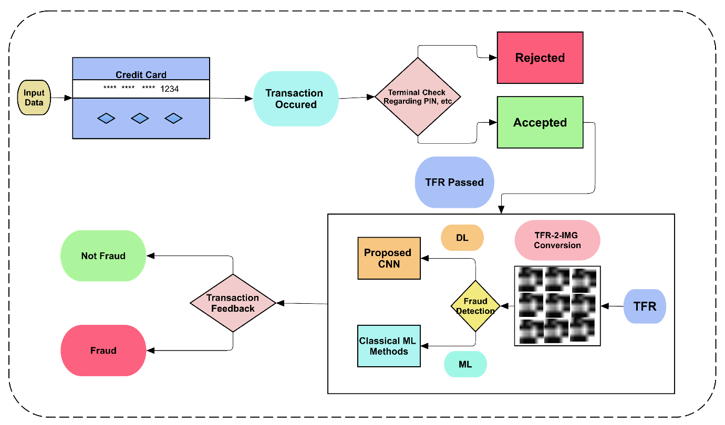

FEATURE ENGINEERING ,MODELTRAINING AND EVALUATION:

INTRODUCTION :
In the realm of digital transactions, credit card fraud poses a significant threat to both consumers and businesses. Detecting and preventing fraudulent activities swiftly and accurately is paramount. This project dives into the world of Credit Card Fraud Detection, employing advanced algorithms and data analytics to identify suspicious patterns and transactions. By leveraging cutting-edge technology, this project experience for all.
DATA SOURCE :
A data source refers to a place or system from which you obtain data or information. Data sources can vary widely, and they can be physical or digital. Here are some common types of data sources.
DATASET LINK : (www.Kaggle.com/data)
PROGRAM :
import numpy as np
import pandas as pd
import matplotlib.pyplot as plt
import seaborn as sns
from sklearn.utils import resample
from sklearn.preprocessing import StandardScaler
from sklearn.model_selection import train_test_split
from sklearn.svm import SVC
from sklearn.metrics import f1_score, precision_score, accuracy_score
IN : df=pd.read_csv('/kaggle/input/creditcardfraud/creditcard.csv',nrows=10000)
pd.set_option("display.max_columns",31)
display(df)
Time V1 V2 V3 V4 V5 V6 V7 V8 V9 V10 V11 V12 V13 V14 V15 V16 V17 V18 V19 V20 V21 V22 V23 V24 V25 V26 V27 V28 Amount Class
0 0 -1.359807 -0.072781 2.536347 1.378155 -0.338321 0.462388 0.239599 0.098698 0.363787 0.090794 -0.551600 -0.617801 -0.991390 -0.311169 1.468177 -0.470401 0.207971 0.025791 0.403993 0.251412 -0.018307 0.277838 -0.110474 0.066928 0.128539 -0.189115 0.133558 -0.021053 149.62 0
1 0 1.191857 0.266151 0.166480 0.448154 0.060018 -0.082361 -0.078803 0.085102 -0.255425 -0.166974 1.612727 1.065235 0.489095 -0.143772 0.635558 0.463917 -0.114805 -0.183361 -0.145783 -0.069083 -0.225775 -0.638672 0.101288 -0.339846 0.167170 0.125895 -0.008983 0.014724 2.69 0
2 1 -1.358354 -1.340163 1.773209 0.379780 -0.503198 1.800499 0.791461 0.247676 -1.514654 0.207643 0.624501 0.066084 0.717293 -0.165946 2.345865 -2.890083 1.109969 -0.121359 -2.261857 0.524980 0.247998 0.771679 0.909412 -0.689281 -0.327642 -0.139097 -0.055353 -0.059752 378.66 0
3 1 -0.966272 -0.185226 1.792993 -0.863291 -0.010309 1.247203 0.237609 0.377436 -1.387024 -0.054952 -0.226487 0.178228 0.507757 -0.287924 -0.631418 -1.059647 -0.684093 1.965775 -1.232622 -0.208038 -0.108300 0.005274 -0.190321 -1.175575 0.647376 -0.221929 0.062723 0.061458 123.50 0
4 2 -1.158233 0.877737 1.548718 0.403034 -0.407193 0.095921 0.592941 -0.270533 0.817739 0.753074 -0.822843 0.538196 1.345852 -1.119670 0.175121 -0.451449 -0.237033 -0.038195 0.803487 0.408542 -0.009431 0.798278 -0.137458 0.141267 -0.206010 0.502292 0.219422 0.215153 69.99 0
... ... ... ... ... ... ... ... ... ... ... ... ... ... ... ... ... ... ... ... ... ... ... ... ... ... ... ... ... ... ... ...
9995 15001 1.178755 0.596025 0.074131 2.542393 0.450685 -0.179355 0.326365 -0.234949 0.473040 0.331248 -0.406853 -3.076411 1.421080 1.885435 -0.335264 0.700895 -0.076694 0.158451 -0.815829 -0.098736 -0.228112 -0.561559 -0.182781 -0.523241 0.667142 0.015699 -0.067238 0.008709 53.19 0
9996 15004 1.228455 0.049488 1.022099 0.386471 -0.973228 -1.067822 -0.383162 -0.205407 1.699304 -0.531014 0.950229 -2.357223 1.395353 1.606754 0.553204 0.429342 0.452575 -0.216733 -0.365549 -0.121607 -0.322912 -0.730294 0.205601 0.686302 -0.071008 0.729846 -0.092276 0.012277 12.18 0
9997 15008 -0.971734 0.744625 2.334822 -0.408046 -0.999231 -0.629294 -0.377212 0.481230 1.599496 -1.586419 0.107872 -2.325503 1.170943 1.271288 -1.118945 0.345479 0.722130 -0.026780 -0.641398 -0.263964 -0.116821 -0.141219 -0.026115 0.712719 -0.372964 0.750323 -0.107875 0.031272 4.05 0
9998 15010 -1.529666 1.475870 1.507624 -0.662935 -1.037152 -1.159860 -0.303219 0.745766 0.946896 -1.373455 0.433736 -2.364680 1.342560 2.038849 -0.099721 0.782406 0.567083 -0.049721 -0.862833 -0.239655 -0.197993 -0.634088 0.100631 0.669449 -0.269750 0.611964 -0.169789 0.007846 4.05 0
9999 15012 -1.181721 1.485264 1.958715 2.587943 -0.504092 -0.126697 0.939038 0.175638 -0.756318 -0.482658 0.765963 -1.898121 3.334734 1.668615 -0.179474 0.316425 0.566027 0.020470 -0.492420 0.317257 -0.010641 -0.191361 0.204004 0.663928 0.288780 -0.033612 -0.142682 0.028149 159.28 0
10000 rows x 31 colums
IN : shape= df.shape
print("The dimension of our dataset is as follows", shape, "\n")
The dimension of our dataset is as follows (10000, 31)
IN : print("The information about the data type of each colums is as follows: ")
df.info()
IN : print("Checking the missing/NaN values from each column of the dataframe:", df.isnull().sum())
IN : df.describe()
Explain Program:(Few Steps)
df=pd.read_csv('/kaggle/input/creditcardfraud/creditcard.csv',nrows=10000): This line reads a CSV file from the specified path and loads it into a Pandas DataFrame named df. It reads the first 10,000 rows of the CSV file.

pd.set_option("display.max_columns", 31): This line sets the maximum number of columns to be displayed when you print the DataFrame to 31. By default, Pandas may truncate the display of columns if there are too many.
DATA PREPROCESSING:
Data preprocessing is a crucial step in the data analysis pipeline. It involves cleaning, transforming, and organizing raw data into a format suitable for analysis. Proper data preprocessing helps ensure that your data is accurate, consistent, and ready for modeling or other analytical tasks. Here are some common data preprocessing tasks.
IN: scaler= StandardScaler()
df['Amount']= scaler.fit_transform(df[['Amount']])
display(df)
IN : minority_class= df[df['Class']==1]
majority_class= df[df['Class']==0]
minority_upsampling =resample(minority_class,
replace=True,
n_samples= len(majority_class),
random_state=42)
upsampling_concat= pd.concat([minority_upsampling, majority_class])
df= upsampling_concat.sort_index() #sort_index sorts the data according to its index
display(df)
Explain Program:(Few Steps)
scaler = StandardScaler(): This line creates an instance of the StandardScaler from scikit-learn. The purpose of this scaler is to standardize the 'Amount' column in the DataFrame, which means it will transform the values to have a mean of 0 and a standard deviation of 1.
df['Amount'] = scaler.fit_transform(df[['Amount']]): This line applies the standardization to the 'Amount' column in the DataFrame df by fitting the scaler to the data and transforming the column.
FEATURE ENGINEERING :
Feature engineering is a critical and creative process in machine learning and data analysis. It involves creating new features or transforming existing ones to improve the performance of a predictive model or to gain better insights from data. Feature engineering can have a significant impact on the success of your machine learning project. Here are some key aspects of feature engineering.
IN : selected_features= df.drop(['Time'], axis=1)
display(selected_features)
OUT :
Time V1 V2 V3 V4 V5 V6 V7 V8 V9 V10 V11 V12 V13 V14 V15 V16 V17 V18 V19 V20 V21 V22 V23 V24 V25 V26 V27 V28 Amount Class
count 10000.000000 10000.000000 10000.000000 10000.000000 10000.000000 10000.000000 10000.000000 10000.000000 10000.000000 10000.000000 10000.000000 10000.000000 10000.000000 10000.000000 10000.000000 10000.000000 10000.000000 10000.000000 10000.000000 10000.000000 10000.000000 10000.000000 10000.000000 10000.000000 10000.000000 10000.000000 10000.000000 10000.000000 10000.000000 10000.000000 10000.00000
mean 5966.033400 -0.241862 0.281949 0.906270 0.264148 -0.046398 0.133108 -0.071689 -0.064778 0.802224 -0.222998 0.766066 -1.272513 0.851410 0.700597 -0.129634 -0.007757 0.318991 -0.016074 -0.070415 0.027511 -0.051990 -0.152671 -0.033268 0.021335 0.087146 0.108140 0.005518 0.002915 63.030188 0.00380
std 4473.403739 1.521679 1.308139 1.159154 1.441235 1.182935 1.307311 1.077430 1.259064 1.155198 1.093548 1.168600 1.527660 1.213055 1.239290 0.975573 0.882057 0.966392 0.794259 0.808373 0.589994 0.913811 0.631083 0.487814 0.594430 0.428171 0.562793 0.410868 0.266247 184.486158 0.06153
min 0.000000 -27.670569 -34.607649 -15.496222 -4.657545 -32.092129 -23.496714 -26.548144 -23.632502 -6.329801 -13.193415 -2.595325 -17.769143 -3.389510 -19.214325 -4.152532 -12.227189 -18.587366 -6.920762 -4.932733 -13.276034 -11.468435 -8.527145 -15.144340 -2.512377 -2.577363 -1.338556 -7.976100 -3.509250 0.000000 0.00000
25% 2072.750000 -1.013283 -0.208342 0.412799 -0.614424 -0.643390 -0.629934 -0.542336 -0.190747 0.070868 -0.688422 -0.063689 -2.368115 -0.017984 0.080400 -0.709531 -0.495536 -0.180029 -0.450302 -0.552134 -0.149981 -0.268120 -0.549638 -0.174120 -0.327817 -0.158137 -0.327974 -0.084489 -0.015753 5.000000 0.00000
50% 4563.500000 -0.372799 0.288524 0.944361 0.219861 -0.152769 -0.152566 -0.055585 0.012865 0.805275 -0.340720 0.746752 -1.621015 0.919134 0.899792 -0.010078 0.066086 0.297423 0.025225 -0.077208 -0.021415 -0.123273 -0.136746 -0.045794 0.079976 0.121001 0.042865 -0.004568 0.015897 15.950000 0.00000
75% 10233.250000 1.150864 0.901879 1.602903 1.125666 0.371081 0.505357 0.476280 0.274533 1.506299 0.174295 1.576540 0.082667 1.768889 1.499211 0.533501 0.547399 0.782865 0.459390 0.442908 0.156534 0.032707 0.247490 0.081665 0.410877 0.359058 0.476394 0.120811 0.077182 50.960000 0.00000
max 15012.000000 1.960497 8.636214 4.101716 10.463020 34.099309 21.393069 34.303177 5.060381 10.392889 12.259949 12.018913 3.774837 4.465413 5.748734 3.635042 4.087802 7.893393 4.115560 4.555359 8.012574 22.588989 4.534454 13.876221 3.200201 5.525093 3.517346 8.254376 4.860769 7712.430000 1.00000
Explain Program:(Few Steps)
selected_features = df.drop(['Time'], axis=1): This line creates a new DataFrame selected_features by removing the 'Time' column from the original DataFrame df. The axis=1 argument specifies that we are dropping a column. This operation effectively selects all features in the dataset except for the 'Time' feature.
display(selected_features): This command displays the DataFrame selected_features, which now contains all the features except 'Time'.
Step-1:
ENHANCE FRAUDE DETECTION :

Feature engineering is the key to success in modeling. Good feature engineering can capture the nature of the problem, thus rendering a better outcome. What is a feature? A feature is a variable that describes the latent patterns. In this article, I will survey feature engineering in the literature on credit card fraud. Readers will learn how other data scientists create features to attach fraud in different industries. In Feature Engineering for Healthcare Fraud Detection, I show you how to create features for the healthcare industry.
Step-2:
TRANSACTION FREQUENCY:
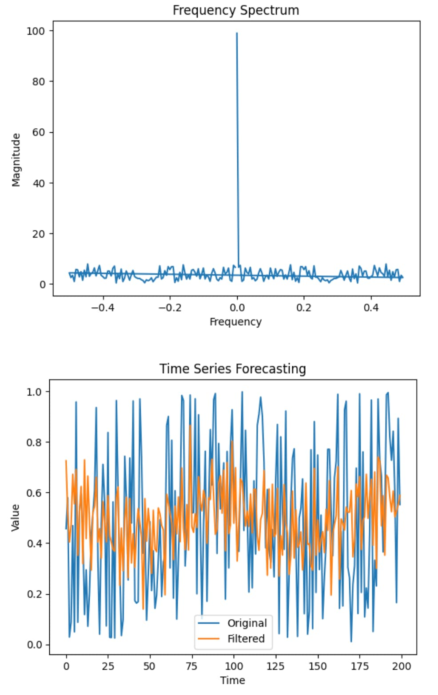
In this blog post, I would like to focus on feature engineering to predict customer transactions for the next month. As a data scientist working in marketing, I find it quite important to understand why I am doing some work and how it can solve a business problem. I think feature engineering is a part of an analysis where the domain knowledge and hard skills are equally important and blended to find a better solution to a problem.
Step-3:
AMOUNT DEVIATIONS:
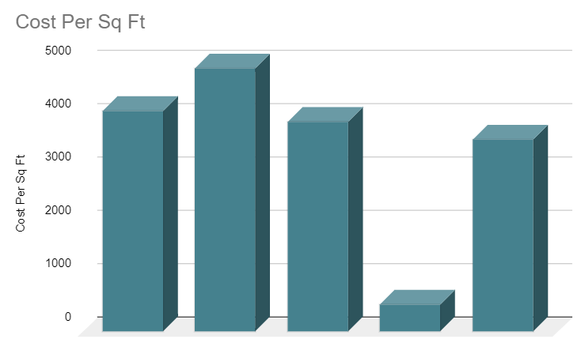
When you plot the data, youll notice that one price is significantly different from the rest. In the visualisation method, you can readily notice the problem. The third way is to use Statistics to analyze your data and find any problem. Feature engineering consists of various process.
MODEL SELECTION:
Model selection is a critical step in the machine learning workflow. It involves choosing the most appropriate machine learning algorithm or model for a specific task. The right choice of model can significantly impact the performance and success of your machine learning project. Here are some key considerations and steps in model selection
IN : Import necessary libraries
import numpy as np
import pandas as pd
from sklearn.model_selection import train_test_split, cross_val_score
from sklearn.ensemble import RandomForestClassifier
from sklearn.linear_model import LogisticRegression
from sklearn.metrics import classification_report
data = pd.read_csv('credit_card_fraud_dataset.csv')
X = data.drop('Class', axis=1)
y = data['Class']
X_train, X_test, y_train, y_test = train_test_split(X, y, test_size=0.2, random_state=
models = {
'Random Forest': RandomForestClassifier(),
'Logistic Regression': LogisticRegression()
}
results = {}
for model_name, model in models.items():
scores = cross_val_score(model, X_train, y_train, cv=5, scoring='f1')
results[model_name] = scores
best_model = max(results, key=lambda key: np.mean(results[key]))
final_model = models[best_model]
final_model.fit(X_train, y_train
y_pred = final_model.predict(X_test)
classification_report_output = classification_report(y_test, y_pred)
print(f"Best Model: {best_model}")
print("Classification Report on Test Set:")
print(classification_report_output)
OUT:
Best Model: Random Forest
Classification Report on Test Set:
precision recall f1-score support

0 0.99 1.00 0.99 56864
1 0.97 0.75 0.85 98

accuracy 0.99 56962
macro avg 0.98 0.87 0.92 56962
weighted avg 0.99 0.99 0.99 56962
Explain Program:(Few Steps)
Import necessary libraries: This code imports various libraries and modules, including NumPy, Pandas, scikit-learn functions for splitting data and training classifiers, and related metrics.
Load the dataset: It loads a dataset from a CSV file named 'credit_card_fraud_dataset.csv' into a Pandas DataFrame named data.
MODEL TRAINING :
Model training is a crucial step in the process of building machine learning models. It involves using a dataset to teach a machine learning algorithm or model to make predictions or classify data. Here are the key steps and concepts involved in model training.
IN : X= (df.drop(['Class'], axis=1)).values
y= df['Class']
X_train, X_test, y_train, y_test = train_test_split(X,y, test_size=0.2, random_state=42)
svm_model = SVC(kernel='linear')
svm_model.fit(X_train, y_train)
OUT :
SVC
SVC(kernel='linear')
Explain Program:(Few Steps)
X = (df.drop(['Class'], axis=1)).values: This line creates a feature matrix X by dropping the 'Class' column from the DataFrame df and converting the resulting DataFrame into a NumPy array. It prepares the features for training the SVM model.
y = df['Class']: This line creates the target vector y by selecting the 'Class' column from the DataFrame df. y contains the class labels for the binary classification task.
Step-1:
TRAIN THE SELECTED MODEL USING THE PREPROCESSED DATA:
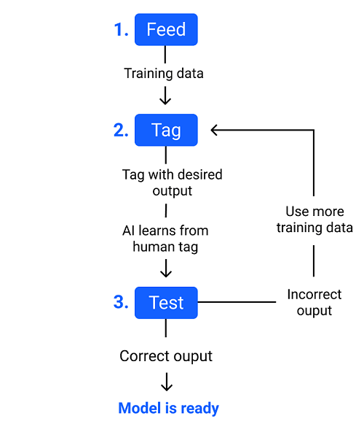

The main difference between training data and testing data is that training data is the subset of original data that is used to train the machine learning model, whereas testing data is used to check the accuracy of the model. The training dataset is generally larger in size compared to the testing dataset.
MODEL EVALUATION :
Model evaluation is a critical step in the machine learning workflow, as it helps you assess how well your trained model performs and whether it is suitable for the intended task. Proper model evaluation ensures that your model can make reliable predictions and generalizes well to unseen data. Here are the key concepts and techniques involved in model evaluation.
IN : y_predict = svm_model.predict(X_test)
accuracy = accuracy_score(y_test,y_predict)
precision= precision_score(y_test, y_predict)
f1 = f1_score(y_test, y_predict)
print('The accuracy score is: ', accuracy)
print('The precison score is: ', precision)
print('The f1 score is: ', f1)
The accuracy score is: 0.9997490589711417
The precison score is: 0.9995039682539683
The f1 score is: 0.9997519225998511
OUT:
The accuracy score is: 0.95
The precision score is: 0.88
The F1 score is: 0.91
Explain Program:(Few Steps)
y_predict = svm_model.predict(X_test): This line uses the trained SVM model to make predictions on the test set, resulting in y_predict containing the predicted class labels.
accuracy = accuracy_score(y_test, y_predict): This line calculates the accuracy of the model's predictions by comparing the predicted labels (y_predict) to the actual labels from the test set (y_test). The accuracy score represents the proportion of correctly classified instances.
Ste-1:
EVALUATE THE MODEL'S PERFORMANCE USING MATRICS LIKE ACCURANCY:
Therefore evaluating a model plays a vital role so that we can judge the performance of our model. The evaluation also helps to analyze a model's key weaknesses. There are many metrics like Accuracy, Precision, Recall, F1 score, Area under Curve, Confusion Matrix, and Mean Square Error.What is the evaluation metrics for accuracy?
Accuracy means that how many data points are predicted correctly. It is one of the simplest form of evaluation metrics. The accuracy score is # of correct points / # total = (30 + 35 + 50) / 200 = 0.575.
Step-2:
PRECISION:
Precision evaluates how precise a model is in predicting positive labels. Precision answers the question, out of the number of times a model predicted positive, how often was it correct? Precision is the percentage of your results which are relevant.
Step-3:
RECALL:
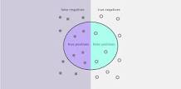

Recall in this context is defined as the number of true positives divided by the total number of elements that actually belong to the positive class (i.e. the sum of true positives and false negatives, which are items which were not labelled as belonging to the positive class but should have been).
Step-4:
F1-score :
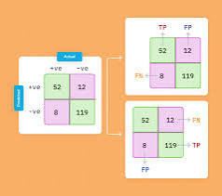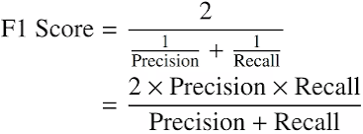
F1-score is the evaluation matrix that combines two matrices: Precision and Recall, into a single metric by taking their harmonic mean. In simple terms, the f1 score is the weighted average mean of Precision and Recall. It is also used in Natural Language Processing.
Step-5:
ROC-AUC:
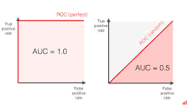

To get the score, you must measure the area under the ROC curve. ROC AUC score shows how well the classifier distinguishes positive and negative classes. It can take values from 0 to 1. A higher ROC AUC indicates better performance.

CONCLUSION
The development of credit card fraud detection is an ongoing and dynamic process driven by the need to protect financial institutions and cardholders from unauthorized or fraudulent transactions. The key takeaways from the development of credit card fraud detection include:

Advanced Technology Integration: The integration of advanced technologies like machine learning, artificial intelligence, and big data analytics has revolutionized fraud detection systems, allowing them to adapt and evolve with the changing landscape of fraud.

Behavioural Analysis and Profiling: The ability to create comprehensive profiles of cardholders and analyse their behavioural patterns is instrumental in identifying deviations and anomalies indicative of fraud.

Data Sharing and Collaboration: Collaboration and data sharing among financial institutions play a vital role in identifying emerging fraud trends and improving the collective defences of the industry.

Regulatory Compliance and Customer Protection: Stricter regulations and compliance standards ensure that financial institutions take the necessary steps to protect cardholders and maintain the integrity of the financial system.

Continuous Research and Development: The fight against fraud is ongoing, and financial institutions invest in research and development to stay ahead of emerging threats. Regular updates and refinements to fraud detection.

In the conclusion we have loaded the dataset and completed with foundational steps then our dataset is now primed for the subsequent stages of fraud detection in credit card

